HEALTH HISTORY FORM
PERSONAL INFORMATION Today’s Date: ________________
Patient Name: _____________________________________________________ Birth Date: ____/_____/________
Current Height: ______Weight: ______(lbs) Weight 1 Year ago: _____Maximum Weight & When:_____________
When during the day is your energy best? _________________ Worst? ___________________________________
Supportive relationship(s)? Yes No | Spiritual Practice? Yes No If yes, ________________________
Any pets/farm animals? Yes No If yes, _______________________________________________________
Have you lived or traveled outside of the United States? Yes No If so, when & where? _________________ _____________________________________________________________________________________________
Have you or your family recently experienced any major life changes? Yes No If yes, please comment:
_____________________________________________________________________________________________
Have you experienced any major losses in life? Yes No If yes, please comment: _______________________
_____________________________________________________________________________________________
Do you enjoy your work? Yes No | Do you take vacations? Yes No
Do you spend time outside? Yes No
Stress level on a scale of 0-10 (10=most): ____ Source(s) of stress:_______________________________________
Stress Management:_____________________________________________________________________________
Are you currently under the care of a physician? Yes No If so, with whom: _________________________
If not receiving health care, when did you last receive health care? ________________________________________
What is/was the reason?__________________________________________________________________________
What are your most important health concerns and what treatments have been used?
- ____________________________________Treatment Used:________________________________________

- ____________________________________Treatment Used:________________________________________

- ____________________________________Treatment Used:________________________________________

- ____________________________________Treatment Used:________________________________________

- ____________________________________Treatment Used:________________________________________
What led you to choose this clinic? ________________________________________________________________
What three expectations do you have from today’s visit at our clinic?
- __________________________________________________________________________________________
- __________________________________________________________________________________________
- __________________________________________________________________________________________

What three long-term expectations do you have from working with our clinic?
- __________________________________________________________________________________________
- __________________________________________________________________________________________
- __________________________________________________________________________________________
How committed are you to addressing the underlying causes of your signs and symptoms that may relate to your lifestyle?
(0 = not committed and 10 = completely committed). Please circle.
0 1 2 3 4 5 6 7 8 9 10
What types of daily or weekly lifestyle habits do you feel support or strengthen your health?
_____________________________________________________________________________________________
What types of daily or weekly lifestyle habits do you feel DO NOT fully support your health?
_____________________________________________________________________________________________
What obstacles or challenges do you potentially anticipate that may undermine your health and following through on your treatment?
_____________________________________________________________________________________________
Who do you know that will sincerely support you consistently with the lifestyle change you will be making to regain your health and vitality?
_____________________________________________________________________________________________
What do you love doing; what brings you joy?
_____________________________________________________________________________________________
MAIN INTERESTS OR HOBBIES
_____________________________________________________________________________________________
_____________________________________________________________________________________________
Wellness is achieved through various aspects of our lives. Using this pie chart, please shade your level of satisfaction of each area. Start shading from the center out to the edge of the circle. For example, if you are 50% satisfied in your career, you will shade starting from the center out and fill in half of that section of the pie chart (5 rings or bands). If you are 100% satisfied in your financial/money, then shade all 10 bands or rings the chart.
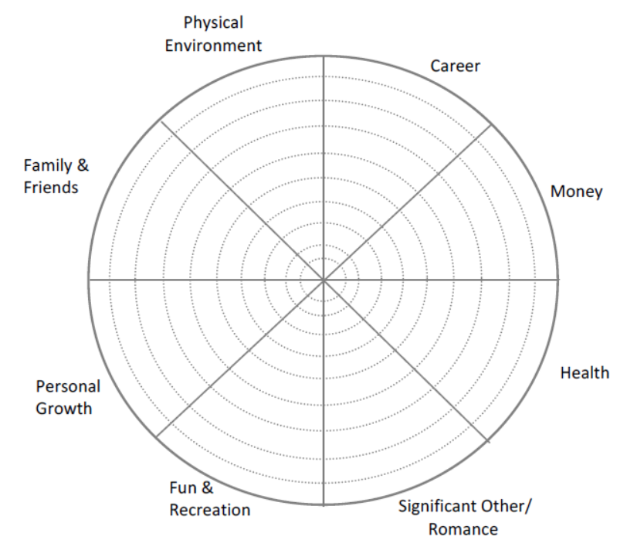
FAMILY HISTORY
Do you have a family history of any of the following (please check all that apply)?
Cancer | Diabetes | Heart Disease | High Blood Pressure
Kidney Disease | Epilepsy | Arthritis | Glaucoma
High Cholesterol | Stroke/TIA | Anemia | Mental Health Illness
Asthma | Hay Fever | Hives | Liver Disease
Any other relevant family history?_______________________________________________________________
CHILDHOOD/EARLY ADOLESCENT ILLNESSES
Which of the following have you had as a child?
Asthma | Mumps | Shingles | EBV (Mononucleosis)
Chicken Pox | Measles | Chronic ear Infections | CMV (Cytomegalovirus)
HOSPITALIZATIONS, SURGERIES, IMAGING
What hospitalizations, surgeries, X-Rays, CAT Scans, EEG’s or EKG’s have you had?
________________________________________________________________________________Year ________
________________________________________________________________________________Year ________
________________________________________________________________________________Year ________
________________________________________________________________________________Year ________
ALLERGIES
Please list allergies: environmental, food(s), drug(s)
_____________________________________________________________________________________________
_____________________________________________________________________________________________
CURRENT MEDICATIONS
Please list all prescription medications, over the counter medications, vitamins and supplements you are taking (including herbs):

EXERCISE AND/OR PHYSICAL ACTIVITIES
_____________________________________________________________________________________________
SLEEP HYGIENE
_____________________________________________________________________________________________
Bedtime: ______Wakeup Time: ____Hard to Fall & Stay asleep Unrefreshed upon waking Sleep well

